CURRICULAM VITAE

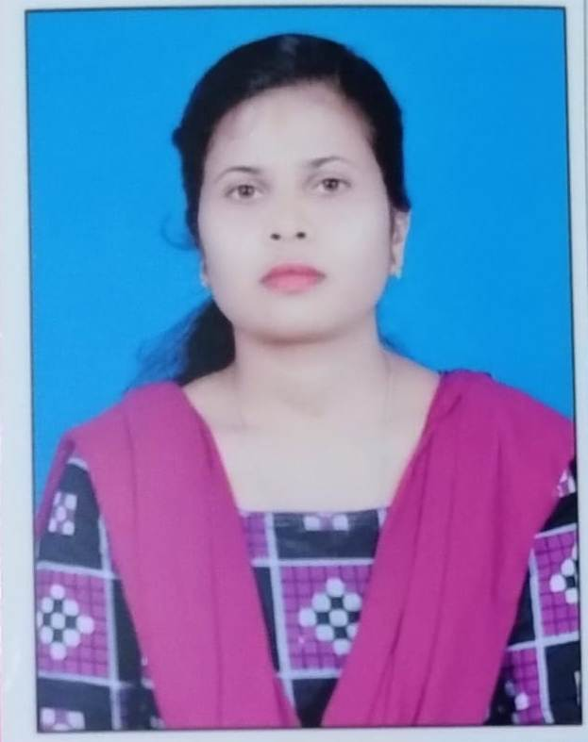

LIPIKA GOUDA
D/O- SUBASH CHANDRA GOUDA
At- Panchayat Colony, Ambaguda ,
Post- Ambaguda ,
Block- Jeypore
Dist- Koraput Email: goudalipika161@gmail.com
State- ODISHA Cell: 9777854055
Pin- 764005
________________________________________________________________________________

CAREER OBJECTIVE / VALUE PROFILE:

My important career objective in life is to associate with such progressive institution that give me Scope to apply my knowledge and skill, seek a Challenging and interesting job that encourages creativity and provided to exposure professional and personal growth along with the institution.

EDUCATION PROFILE:

SL.  NO | Name of  the course | Specification of  the course | Year | Name of the  Board/  University | Total  Marks | Marks  Secured | Percentage  % | Division
1 | M.A | Post Graduate in sociology | 2022 | Berhampur University | 2000 | 1420 | 71% | 1st
2 | Degree | +3 Arts | 2020 | Berhampur University | 2400 | 1683 | 70% | 1st
3 | CHSE | +2 Arts | 2017 | CHSE, BBSR, ORISSA | 600 | 288 | 48% | 3rd
4 | HSE | 10th | 2015 | BSE, ORISSA | 600 | 470 | 78% | 1st

CO-CURRICULAR AND EXTRA CURRICULAR ACTIVITIES:

Year
- 2022 Post Graduate Diploma in Computer Application, (PGDCA).

- 2022-24 Two years of working experience as Guest faculty in Sociology in Government
College, Koraput

Strength:

- Self Motivation, Positive thinking and Hardworking.

SKILLS AND ABILITIES

- Dedicated sincere and hard working.
- Able to identify problem and solve them.
- Interest to learn and adopt new thing and techniques.

HOBBIES

Reading: Read various Story books, current affairs, articles and
Motivational books during my leisure time.

PERSONEL PROFILE:

- Date of Birth : 11th march 2000
- Religion : Hindu
- Nationality : Indian
- Gender : Female
- Marital Status : Un-Married
- Languages Known : English, Hindi, Oriya

ADDRESS

LIPIKA GOUDA
D/O- SUBASH CHANDRA GOUDA
At- Panchayat colony, Ambaguda
Post- Ambaguda ,
Block- Jeypore
Dist.- Koraput
State- Odisha
Pin- 764005
DECLARATION:
I do here by declare that the above written particulars are correct and true to the best of my
Knowledge and belief.

Place : Ambaguda (Lipika Gouda )
Date : Signature of the Candidate

