RESUME
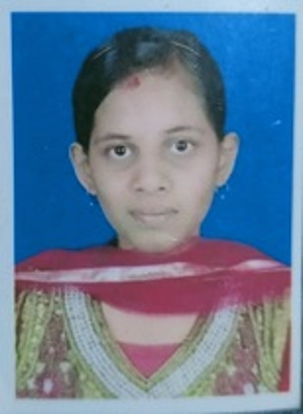

Name : BHAVANI DAS
Father’s Name : GOKULA CHANDRA DAS
Date of Birth : 05th May 2001
Sex : Female
Marital Status : UN-Married
Caste : General
Education & Qualification:
Arts in Political Science
Examination Passed | Board / University | Year of passing | Division/ Class | % of marks
10TH | Board of Secondary Education, Odisha | 2016 | 1st | 66.5%
+2 | Council Of Higher Secondary Education, Odisha | 2018 | 1st | 70.83%
+3 | Berhampur University, Odisha | 2021 | 1st | 76%
P.G. | Khallikote Unitary University, Berhampur | 2023 | 1st | 70%

Address : At: Jayanagar, Paik Street, 2nd Lane, Jeypore(764005 )
Mobile : 9337035346
Computer knowledge : PGDCA & TALLY
Language Known : Hindi, Odia, English

STRENGTH

- Adaptability
- Punctuality, disciplined, hard-working, honest.
- Have a keen desire to learn & grow further.
- Friendly Nature

EXPERIENCE
Teaching Experience of One year at Private School (Eng Medium)

DECLARATION

I do hereby declare that the above stated information is true to
the best of my knowledge and belief.

Place:
Date:

